**Name:**



**Year 11 Revision Planner**

Get Ready for Summer GCSE Exams 2025

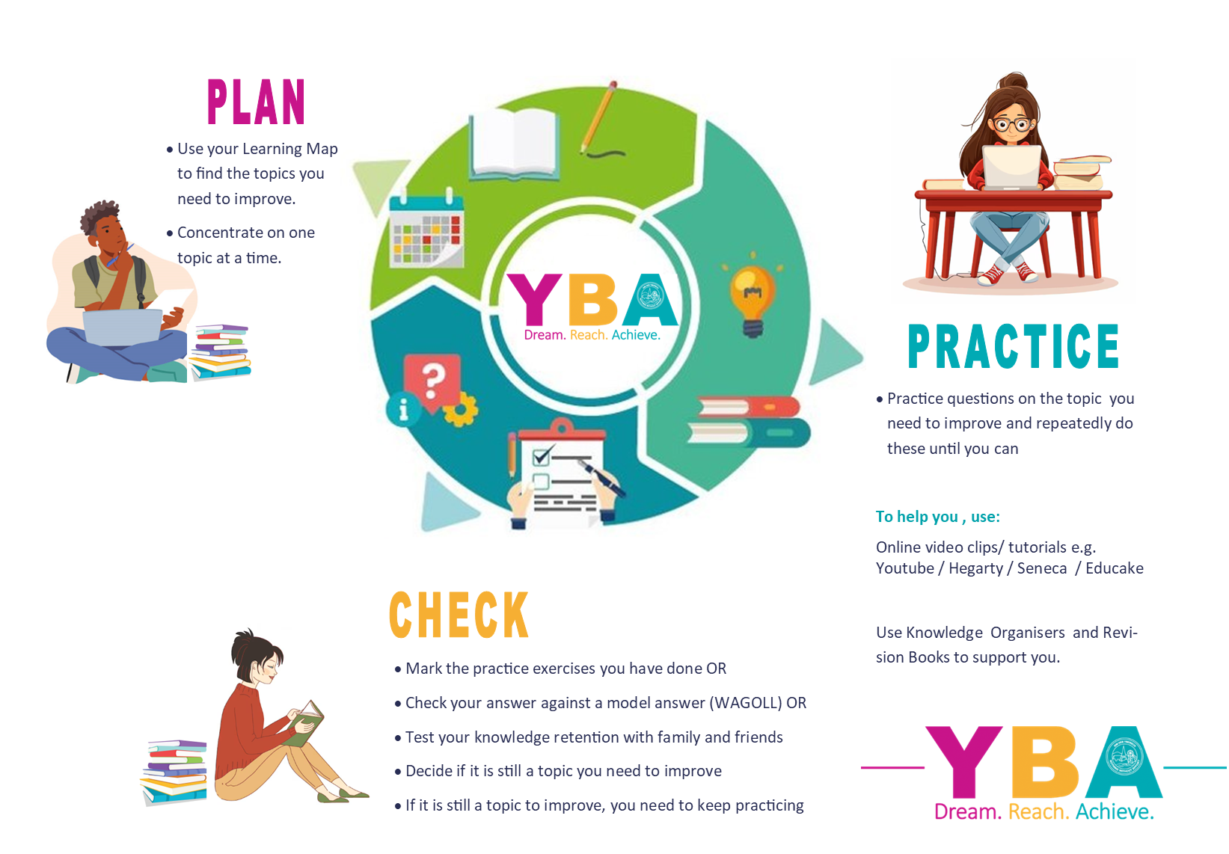e class: 3S2U88

do I prioritise my child’s revision?



**6 habits** of highly successful students

1. **Spaced Practice:** NO CRAMMING. Short, regularly spaced-out study periods over time.
2. **Interleaving Topics:** SWITCH topics regularly, making links between ideas.
3. **Elaborate:** ASK, EXPLAIN AND CONNECT. Explain how or how things work and connect them to your daily life and experiences.
4. **Concrete Examples:** look for real life EXAMPLES you can relate to understand an idea you are learning.
5. **Duel Coding:** combine WORD AND VISUAL materials giving you 2 ways of remembering information
6. **Retrieval Practice:** put all of your revision away and RECALL EVERYTHING YOU KNOW about a topic. Check it against your revision materials later.

**YOU make this happen. We will help you, but the success will be yours. We all want you to do well and everyone wants to help and encourage you!**

**GO FOR IT!**

Revision Timetable – from now to your first mock exam

(**Two 45min sessions EVERY night. Write down the subject and topic which you need to improve in .**

|  |  |  |  |  |  |  |
| --- | --- | --- | --- | --- | --- | --- |
| **Revision Times** | | **1st 45-minute Revision Session** | | **2nd 45-minute Revision Session** | | |
| Example | | English Literature  The character arc of Macbeth | | Science  12+ mark question on Biology Paper 2 | | |
| Monday | 24 Mar |  | |  | | |
| Tuesday | 25 Mar |  | |  | | |
| Wednesday | 26 Mar |  | |  | | |
| Thursday | 27 Mar |  | |  | | |
| Friday | 28 Mar |  | |  | | |
| Saturday | 29 Mar |  | |  | | |
| Sunday | 30 Mar |  | |  | | |
| Monday | 31 Mar |  | |  | | |
| Tuesday | 1 Apr |  | |  | | |
| Wednesday | 2 Apr |  | |  | | |
| Thursday | 3 Apr |  | |  | | |
| Friday | 4 Apr |  | |  | | |
| Saturday | 5 Apr |  | |  | | |
| Sunday | 6 Apr |  | |  | | |
| Monday | 7 Apr |  | |  | | |
| Tuesday | 8 Apr |  | |  | | |
| Wednesday | 9 Apr |  | |  | | |
| Thursday | 10 Apr |  | |  | | |
| Friday | 11 Apr |  | |  | | |
| Saturday | 12 Apr |  | |  | | |
| Sunday | 13 Apr |  | |  | | |
| Monday | 14 Apr |  | |  | | |
| Tuesday | 15 Apr |  | |  | | |
| Wednesday | 16 Apr |  | |  | | |
| Thursday | 17 Apr |  | |  | | |
| Friday | 18 Apr |  | |  | | |
| Saturday | 19 Apr |  | |  | | |
| Sunday | 20 Apr |  | |  | | |
| Monday | 21 Apr |  | |  | | |
| Tuesday | 22 Apr |  | |  | | |
| Wednesday | 23 Apr |  | |  | | |
| Thursday | 24 Apr |  | |  | | |
| Friday | 25 Apr |  | |  | | |
| Saturday | 26 Apr |  | |  | | |
| Sunday | 27 Apr |  | |  | | |
| Monday | 28 Apr |  | |  | | |
| Tuesday | 29 Apr |  | |  | | |
| Wednesday | 10 Apr |  | |  | | |
| Thursday | 1 May |  |  |  | | |
| Friday | 2 May |  | |  | | |
| Saturday | 3 May |  | |  | | |
| Sunday | 4 May |  | |  | | |
| Monday | 5 May |  | |  | | |
| Tuesday | 6 May |  | |  | | |
| Wednesday | 7 May |  | |  | | |
| Thursday | 8 May |  |  |  | |  |
| Friday | 9 May |  |  |  | | |
| Saturday | 10 May |  | |  | | |
| Sunday | 11 May |  | |  | | |
| Monday | 12 May |  |  |  | | |
| Tuesday | 13 May |  |  |  |  | |
| Wednesday | 14 May |  |  |  |  | |
| Thursday | 15 May |  |  |  |  | |
| Friday | 16 May |  |  |  |  | |
| Saturday | 17 May |  | |  | | |
| Sunday | 18 May |  | |  | | |
| Monday | 19 May |  |  |  | | |
| Tuesday | 20 May |  | |  |  | |
| Wednesday | 21 May |  |  |  | | |
| Thursday | 22 May |  |  |  | | |
| Friday | 23 May |  |  |  | | |
| Saturday | 24 May |  | |  | | |
| Sunday | 25 May |  | |  | | |
| Monday | 26 May |  | |  | | |
| Tuesday | 27 May |  | |  | | |
| Wednesday | 28 May |  | |  | | |
| Thursday | 29 May |  | |  | | |
| Friday | 30 May |  | |  | | |
| Saturday | 31 May |  | |  | | |
| Sunday | 1 Jun |  | |  | | |
| Monday | 2 Jun |  |  |  | | |
| Tuesday | 3 Jun |  |  |  |  | |
| Wednesday | 4 Jun |  |  |  |  | |
| Thursday | 5 Jun |  |  |  | | |
| Friday | 6 Jun |  | |  |  | |
| Saturday | 7 Jun |  | |  | | |
| Sunday | 8 Jun |  | |  | | |
| Monday | 9 Jun |  |  |  |  | |
| Tuesday | 10 Jun |  |  |  | | |
| Wednesday | 11 Jun |  | |  | | |
| Thursday | 12 Jun |  | |  | | |
| Friday | 13 Jun |  |  |  |  | |
| Saturday | 14 Jun |  | |  |  | |
| Sunday | 15 Jun |  | |  |  | |
| Monday | 16 Jun |  | |  |  | |
| Tuesday | 17 Jun |  | |  |  | |
| Wednesday | 18 Jun |  | |  |  | |