Ysgol Bryn Alyn

Rights, Respect & Equality

Challenging bullying behaviours

Policy formally approved by Full Governing Body/Committee | Date:
Policy Review | ** Date(s): March 2022
Policy Type: | Statutory Policy / Statutory Documents LA Recommended Policy / Document School Policy
Policy Origin i.e: | ** Chair/Headteacher indicate where the policy originates from by circling or highlighting before sending to Clerk LA Model Policy / LA Policy / Welsh Assembly Government Model Policy / Other (If ‘Other’ please detail source below):  Recommended policy written by School
Is this a new or revised policy: | New / Reviewed
Equality Impact Assessment Completed: | Date: EIA Number:
Name of SLT responsible for review and implementation of policy: | A Slinn / A Kipping /R. Ransome / E Williams/ J Ebrey
Chair of Governing Body / Chair of Committee: | Signature:  Date:
Issue No: | 1

Contents

Sections Page No

- Introduction 3

- National Context 3

- Local Context 4

- Aims and Objectives 6

- General Principles 6

- Process and Implementation 6

- Monitoring, Evaluation and Review 8

- Appendices 10

INTRODUCTION

Ensuring the safety and wellbeing of all our children and young people is of paramount importance for the Council, our schools and all educational settings.

Bullying behaviour is an issue which is high on the agenda for us all; Welsh Government, Council, parents, carers, school staff and children and young people. When a child or young person is being bullied the effects can be far-reaching and unquantifiable. There will be distress that can cause changes in behaviour. This could include signs of school avoidance, loss of concentration and result in significant underachievement and wellbeing issues.

It is a requirement for all schools and educational settings to now have a policy which clearly sets out their strategies for preventing and responding to bullying behaviours based on protected characteristics. This guidance provides advice to head teachers and educational staff on how to manage this process most effectively.

It reminds us all that bullying is an endemic social factor so that we all need to be vigilant and proactive in ensuring it has minimal impact on our children and young people. No school or setting can say that bullying never occurs. This guidance will support those who are dealing with the issue.

By taking a proactive approach and addressing bullying effectively we can reduce the instances and the long term impact, by our responses, to both the ‘perpetrator’ and the
‘victim’.

It is expected that all those who work closely with children and young people in the Wrexham Local Authority will adopt and implement this guidance.

NATIONAL CONTEXT
The Welsh Government identifies seven core aims in its ‘Rights to Action’ document, four of which directly link to their priority to reduce bullying these include that every child and young person should:
- enjoy education, training and learning opportunities that are free from personal threat of bullying behaviours;
- experience the best possible mental, social and emotional health, which is free from abuse, victimisation and exploitation;
- be listened to, treated with respect and have their race and cultural identity recognised;
- have a safe home and community which supports emotional wellbeing.

The Welsh Government has also issued specific challenging bullying guidance, ‘Rights, Respect, equality: Statutory guidance for governing bodies of maintained schools’ (2019). The UK has been found to be one of the worst countries for children and young people’s life satisfaction, and bullying is mentioned as a cause of this. The Children’s Society ‘The Good Childhood Report 2017’ puts this into context by saying that bullying behaviour can signal that there are other disadvantages in a child or young person’s life, reflecting low overall life satisfaction.
‘In the face of rising digital threats and broader prejudices expressed online and offline, a focus on challenging bullying is perhaps more vital than ever before.
In Wales and England, there is an increase in reported hate crime (Home Office statistics show a 15% increase in recorded hat crimes across Wales compared to 2016-17 – see www.gov.uk/government/statistics/hate-crime-england-and-wales-2017-to-2018)
revealing the need to challenge discrimination. Thousands of children and young people in Wales have said bullying remains their top priority (in 2016 children told the Children’s Commissioner for Wales that bullying remained their top priority). One of the reasons it regularly tops surveys as a primary concern, is that it affects so many. Children and young people’s calls for action to be taken by adults is supported by an array of research that shows the devastating and long-lasting impact bullying can have, not only to targets but
to perpetrators of bullying and bystanders too. Severe impacts can be long-term,
including poor mental health and reduced well-being.’
Rights, Respect, Equality: Statutory guidance for governing bodies of maintained schools’ (2019)

Preventing and responding to bullying behaviours should be seen within the wider context of work on behaviour and attendance in schools.

LOCAL CONTEXT

The Local Authority (LA) and Council recognises the detrimental effect bullying behaviours have on children and young people and will work proactively to minimise the risks of bullying whenever and wherever it occurs. The LA further recognises that the school day includes extra-curricular activities e.g., breakfast and after school clubs. The school day also includes the journey to and from school.

The Council believes that it is the responsibility of all its services to support schools and educational settings that work with children and young people to:

- develop a challenging bullying policy by translating the local authority policy into one that is appropriate to their own specific context;
- ensure that the development of the policy incorporates awareness-raising activities and consultation with staff, children, governors, parents and carers as appropriate;
- ensure that appropriate support and training is made available to staff;
- ensure that there is recording and monitoring of incidents of bullying behaviours;
- actively listen to and support children and young people;
- act appropriately on information received in order to keep children and young people safe in a positive and secure environment
- ensure that all children and young people feel safe and secure.
- promote the message that all forms of bullying behaviours are unacceptable;
- ensure that all targets of bullying behaviours will be positively supported and heard;
- ensure that those who display bullying behaviours and discriminate against others will also need support;
- report any bullying behaviours they witness as a bystander.
- have a right to the protection of all adults acting on behalf of the LA.

Policies on bullying behaviours should sit comfortably alongside those on behaviour and discipline, child protection and personal, social and health education. Best practice demands that children and young people must be involved in creating solutions, in developing policy and practice and in maintaining agreed strategies and behaviour.

Bullying definition (for the purposes of YBA policy)

Behaviour by an individual or group, usually repeated over time, that intentionally hurts others either physically or emotionally.

This definition has been agreed by the YBA School Council and has been shared with pupils and staff across the school.

‘Bullying is expressed through a range of hurtful behaviours: it can happen face-to-face or in the digital environment. It can be carried out by an individual or group but is generally executed in front of an audience to assert power or popularity. It may involve an element of secrecy so that adults are not aware of it.

Bullying differs from an argument, a fight or friendship fallout in that it:
• is deliberate or intentional
• is generally repeated over time
• involves a perceived imbalance of power between perpetrator and target
• causes feelings of distress, fear, loneliness, humiliation and powerlessness.
It is recognised that a one-off incident can leave a learner traumatised and nervous of reprisals or future recurrence.’
(Rights, Respect, Equality: Statutory guidance for Governing Bodies of maintained schools’ (2019))

The United Nations Convention on the Rights of the Child (UNCRC) is a list of 42 rights for children and young people and it includes the right to:
- Be protected from being hurt or mistreated
- A good quality education that helps you develop your talents and abilities
- Practice your religion
- A safe environment
All pupils should enjoy these rights and respect the rights of others.

Rights of Children and Young Persons (Wales) Measure 2011 ensures that children and young people’s rights are respected in all that is done to support our young people.
At YBA pupils have a right to a safe, good-quality education. Meaning:
- YBA has policies and practices to encourage positive behaviours and challenge bullying
- YBA has a behaviour policy that explains the processes involved
- YBA consults with its pupil body about these policies.
- YBA informs pupils about these policies to support positive behaviours.

AIMS AND OBJECTIVES

- To help create and support a culture of care and consideration for others where bullying behaviour is not acceptable.
- To raise awareness of bullying behaviours and its effects on children and young people’s emotional health and well-being, life chances and achievement
- To establish a consistent, coordinated approach to challenge bullying behaviours at YBA
- To highlight conditions in which bullying behaviours are likely to happen.
- To challenge and stop incidents of bullying behaviours in all its forms. This includes children and young people displaying peer on peer abuse, adults displaying bullying behaviours towards children and young people, as well as children and young people displaying bullying behaviours towards adults.
- To ensure that all stakeholders are aware of this policy and can identify their roles in relation to it.
- To acknowledge that the Council and all those acting on its behalf consider bullying behaviours to be unacceptable and are committed to dealing with it.

GENERAL PRINCIPLES

Wrexham Borough Council seek to provide a safe, secure and positive environment in which all children and young people can maximise their potential using the full range of LA services and facilities available.

The Council believes that all children and young people are entitled to be treated with respect and understanding. They should also be able to undertake any activity without fear of intimidation. Behaviours that undermine these principles are totally unacceptable.

The Council is also committed to the fundamental principle that early intervention strategies and partnership working is crucial to ensuring the protection and wellbeing of all its children and young people.

PROCESS AND IMPLEMENTATION

Schools and educational settings need to fulfil their legal obligations by ensuring an appropriate Challenging Bullying policy is in place. Each Challenging Bullying policy needs to be clear about what bullying is based on protected characteristics and how the setting intends to deal with it.

Account should be taken of the following:

- statements of council principles are reflected in their own challenging bullying policy
- children and young people, parents/carers and the wider school or educational community are involved in preparing and reviewing their policy;
- that their policy document is recognisable and known to all within the school/ educational community;
- a named person has the lead responsibility for co-ordinating and implementing the policy;
- it is made clear that everyone has a responsibility for the safety of others;
- appropriate training on challenging bullying is provided for all staff, children and young people and any other relevant person identified within the school community;
- that they regularly update and raise awareness of adults, children and young people about bullying issues;
- that all staff and volunteers maintain positive relations with children and young people;
- provide and encourage a safe environment in which adults listen positively and discuss the concerns of youngsters around bullying behaviours.

Challenging Bullying policies are most effective when the whole workforce:

- understand the principles and purpose of the Challenging Bullying policy;
- are clear about their responsibility to resolve the problems at the nearest level to the child and young person.
- know what sanctions and behaviour management strategies are in place and where to find support.
- have the requisite skills and knowledge for preventing bullying behaviours and repairing harm.
- understand the needs of vulnerable , including disabled pupils and those with special educational needs.
- know the procedures for referral.
- understand the procedures in relation to safeguarding.

Schools and educational settings should work in partnership to develop links with agencies that might help in countering bullying behaviour. An excellent comprehensive list appears in Rights, Respect, Equality – Statutory Guidance for Governing Bodies of maintained schools (2019) p.74.

All adults, children and young people should be alert to the signs of bullying behaviour.

All schools and educational settings should make a commitment to take effective and appropriate action in countering bullying behaviour. Failure in responding to incidents may be taken as condoning such behaviour.

Schools and educational settings should also develop appropriate mechanisms for:

- making children and young people who allege they have been bullied immediately feel supported; investigating incidents and clearly mapping what actions will be taken following the investigation process.
- recording incidents and subsequent actions.
- giving due consideration to confidentiality issues.
- involving parents and other appropriate organisations.
- ensuring staff are more proactive in certain situations to prevent bullying behaviours.
- monitoring and evaluating the actions taken.

The Directorate of Learning and Skills recommends that schools and educational settings identify how they will ensure that staff training reflects its Challenging bullying policy and practice and where specific training needs have been identified for particular members of staff, those staff members have access to the advice, training and development opportunities appropriate to their needs.

The Lawrence Enquiry and subsequent Macpherson Report (1999) recommends that LA’s and school governors have a duty to create and implement strategies in their schools and educational settings to prevent and address racism. This includes that:
- schools and educational settings should record all racist incidents;
- all recorded incidents are reported to the pupils parents/guardians, school governors and the LA;
- the numbers of racist incidents are published annually on a school by school basis;
- the numbers and self defined ethnic identity of excluded pupils are published annually on a school by school basis.

Schools and educational settings should undertake an audit of where and when bullying behaviours occur and use the information to inform further planning.

The Directorate of Learning and Skills recognises the need to respond to increased levels of public concern around bullying issues. Existing good practice should be further developed and disseminated without over reacting to media pressures

Schools and educational settings should use the WG Guidance on ‘Rights, Respect, Equality’ (2019) as a resource in all incidents relating to bullying. The guidance is comprehensive with an excellent resource section and directory of supportive literature and agencies that can offer advice and guidance on bullying related issues. Please refer to Appendix 2 for a summary of legal responsibilities and Welsh Government Guidance.

MONITORING, EVALUATION AND REVIEW

The Welsh Government recommends that organisations should record all incidents of bullying, including by type and report the statistics to the Local Authority at the end of each term. Schools will be expected to complete a Bullying Incident Reporting Form on a termly basis

The purpose of reporting incidents to the local authority is to enable the gathering of information on the number and nature of bullying incidents and to identify any developing trends. The Directorate of Learning and Skills will analyse the information gathered to identify any issues of particular concern. This will enable the authority to be better informed in the development of appropriate strategies to tackle bullying and to safeguard children and young people. Without the collection and recording of information about bullying incidents, it is difficult to get an accurate picture of the extent of bullying behaviours or to measure how effective strategies are at combating these behaviours.

Schools and educational settings have a specific legal duty to have a race equality policy and monitor its impact on pupils, staff and parents. Schools and educational settings also have a specific duty to eliminate disability related harassment under the Disability Discrimination Act 1995. Schools and educational settings who are monitoring and recording incidents of bullying as described above will evidence how effective strategies are in achieving these goals.

Keeping records of bullying incidents will enable organisations to:

- manage individual cases effectively;
- monitor and evaluate the effectiveness of strategies;
- celebrate the challenging-bullying work of the organisation;
- demonstrate defensible decision making in the event of complaints being made;
- engage and inform multi-agency teams as necessary.

As well as information held on the type and frequency of incidents, it is recommended that of the following types of tackling bullying data is also considered:

- information on what action was taken and the impact this had on the bullying behaviours;
- a range of data from pupil surveys including quantitative data;
- exclusions data relating to bullying behaviours;
- records held by the Attendance and Well-being Service identifying where bullying behaviours is a factor in non-attendance in school;
- parent / carer complaints to the school or the authority regarding bullying behaviours.

School governing bodies should regularly review their schools Challenging Bullying Policy, making it clear in prospectuses and policy documents that bullying behaviours are not going to be tolerated. They should also outline procedures for reporting incidents of bullying detailing what support the individual child or young person can expect to receive. Details of where parents/carers might receive independent support and advice should be made available.

The Directorate of Learning and Skills will monitor how effective schools and other educational settings are through:

- Estyn reports;
- JES MCSI programme of visits
- LA specialist staff visits and reports;
- Internal or Independent reviews;
- School self-evaluation processes;
- Tracking and collating relevant data, as previously outlined in this section.

The work of the Directorate will be monitored through:

- National and local performance indicators;
- Estyn reports;
- Directorate self-evaluation processes;
- Tracking and collating relevant data.

This Policy will be reviewed annually and updated in light of any changes in legislation.
APPENDICES

 |  | Page No
1 a) Types of bullying |  |  | 11 - 12
b) Children & Young Persons’ definition of bullying |  |  | 13
2. Legal responsibilities / Welsh Government guidance |  |  | 14-15
3 a) Bullying advice for Children and Young people |  |  | 16-17
b) Bullying advice for Parents and Carers |  |  | 18-20
4. Tackling Bullying: Estyn Best Practice (website link) |  |  | 20
5 a) YBA Challenging Bullying policy |  |  | 21-24
b) Checklist for Challenging Bullying policy  6 All-Wales Travel Behaviour Code |  |  | 25  26
7 Advice, Counselling & Support Organisations |  | 27 - 30

Appendix 1a)
Types of bullying behaviours

Type | Example
Physical Bullying | - Kicking or hitting  - Prodding, pushing or spitting  - Other physical assault  - Intimidating behaviour  - Interference with physical property
Verbal/Psychological | - Threats or taunts  - Shunning/ostracism  - Name calling/verbal abuse  - humiliation  - Spreading rumours  - Making inappropriate comments in relation to appearance  - Extortion / intimidation
Emotional | - Behaviour intended to isolate, hurt or humiliate someone
Indirect | - Sly or underhand actions carried out behind the target’s back or rumour-spreading
Online | - using any form of technological means, mobile phones, social networks,  - gaming, chat rooms, forums or apps to bully via text, messaging, images or video
Socio-economic Status | - Negative stereotyping, name calling or ridiculing based on financial circumstances
relational aggression | - bullying that tries to harm the target’s relationships or  social status:  - drawing their friends away,  - exploiting a person’s special educational needs (SEN) or long-term illness,  - targeting their family’s social status,  - isolating or humiliating someone or deliberately getting someone into trouble
Sexist | - Use of sexist language  - Negative stereotyping based on gender
Sexual | - Unwanted/inappropriate physical contact  - Sexual innuendo  - Suggestive propositioning  - Distribution/display of pornographic material aimed at an individual  - Graffiti with a sexual content aimed at an individual  - sextortion, so called ‘revenge porn’ and any  misuse of intimate, explicit images of the learner targeted
Prejudice-related | - bullying of a learner or a group of learners because of  prejudice. This could be linked to stereotypes or presumptions about identity. Prejudice-related bullying includes the protected characteristics (age, disability, gender reassignment, pregnancy, race, religion or belief, sex and sexual orientation).  - Prejudice can and does also extend beyond the protected characteristics and can lead to bullying for a variety of other reasons such as social status and background.

Discriminatory bullying should be explicitly discussed in the setting and there must be clear guidelines for dealing with incidents. The Governing Body is required to record all discriminatory incidents that take place in the school and report them to the LA each term on the Excel monitoring form already circulated. All other agencies should follow their service policy with regard to their general duty under the Equality Act 2010 (Statutory Duties) (Wales) Regulations 2011.

Appendix 1b)

Children and Young Persons’ definition of bullying

‘Behaviour by an individual or group, repeated over time, which is meant to hurt someone physically or emotionally.’

Bullying:
- hurts or upsets someone
- targets someone and leaves them feeling powerless to stop it
- happens on purpose
- happens more than once.
(Rights, Respect, Equality – A Guide For Young People (2019) Welsh Government)

Bullying is hurting people, on purpose, over and over again, making them feel sad, afraid and upset.

Bullying can be:

- being unfriendly, nasty, mean, leaving people out, hiding people’s things, threatening.
- using violence e.g. pushing, kicking, hitting, punching
- picking on someone because of their colour, religion, nationality, accent or dress.
- touching someone in a way that is wrong or saying things that make them feel uncomfortable or scared.
- teasing someone because of who they are friends with, how they look or what they like, name-calling, spreading stories, teasing, making fun of people.
- misusing internet chat rooms, sending threatening or nasty e-mails or texts, taking inappropriate photos or videos.

Appendix 2

Legal responsibilities / Welsh Government Guidance

The Education and Inspections Act 2006.
There are a number of statutory obligations on schools with regard to behaviour which establish clear responsibilities to respond to bullying. In particular section 89 of the Education and Inspections Act 2006:

- states that every school must have measures to encourage good behaviour and prevent all forms of bullying amongst pupils. These measures should be part of the school’s behaviour policy which must be communicated to all pupils, school staff and parents
- gives headteachers the ability to ensure that pupils behave when they are not on school premises or under the lawful control of school staff.

The Equality Act 2010
Under the Equality Act 2010, new duties on schools and other public bodies came into force in April 2011. The Act strengthens and simplifies existing equality legislation. The Act brings together existing duties not to discriminate on grounds of race, disability and gender which schools are already bound to comply with, and it extends these to include duties not to discriminate on the grounds of age, sexual orientation, religion or belief, and gender reassignment. It places a requirement on governing bodies and proprietors of schools to eliminate discrimination and promote equal opportunities, some of which they will already be doing. It applies to school policies for tackling prejudice based bullying.

Safeguarding children and young people.
Under the Children Act 1989 a bullying incident should be addressed as a child protection concern when there is ‘reasonable cause to suspect that a child is suffering, or is likely to suffer, significant harm’. Where this is the case, the school staff should report their concerns to their local authority Children’s Services in line with All Wales Child Protection Procedures. Under the Children Act 2004, all agencies have a responsibility to safeguard children and young people and promote their welfare. Even where safeguarding is not considered to be an issue, schools may need to draw on a range of external services to support the pupil who is experiencing bullying, or to tackle any underlying issue which has contributed to a child doing the bullying.

Criminal law
Although bullying in itself is not a specific criminal offence in the UK, it is important to bear in mind that some types of harassing or threatening behaviour – or communications – could be a criminal offence, for example under the Protection from Harassment Act 1997, the Malicious Communications Act 1988, the Communications Act 2003, and the Public Order Act 1986. If school staff, feel that an offence may have been committed they should seek assistance from the police. For example, under the Malicious Communication Act 1988, it is an offence for a person to send an electronic communication to another person with the intent to cause distress or anxiety or to send an electronic communication which conveys a message which is indecent or grossly offensive, a threat, or information which is false and known or believed to be false by the sender.

Bullying outside school premises
Headteachers have a specific statutory power to discipline pupils for poor behaviour outside of the school premises. Section 89(5) of the Education and Inspections Act 2006 gives head teachers the power to regulate pupils’ conduct when they are not on school premises and are not under the lawful control or charge of a member of school staff. This can relate to any bullying incidents occurring anywhere off the school premises, such as on school or public transport, outside the local shops, or in a town or village centre.

Where bullying behaviours outside school is reported to school staff, it should be investigated and acted on. The head teacher should also consider whether it is appropriate to notify the police in their local authority of the actions taken against a pupil. If the misbehaviour could be criminal or poses a serious threat to a member of the public, the police should always be informed.

Other References including Welsh Government Guidance:

- Lawrence Enquiry and Report, 1999
- Rights, Respect, Equality – Statutory Guidance for Governing Bodies of Maintained Schools (2019)
- Rights to Action (based on the United Nations Convention on the Rights of the Child, 2000)
- Rights of Children and young Persons (Wales) Measure 2011
- Learner Travel (Wales) Measure 2008
- Counter-Terrorism 7 Security Act 2015
- Social Services & Wellbeing (Wales) Act 2014

Appendix 3a

Bullying advice for Children and Young People
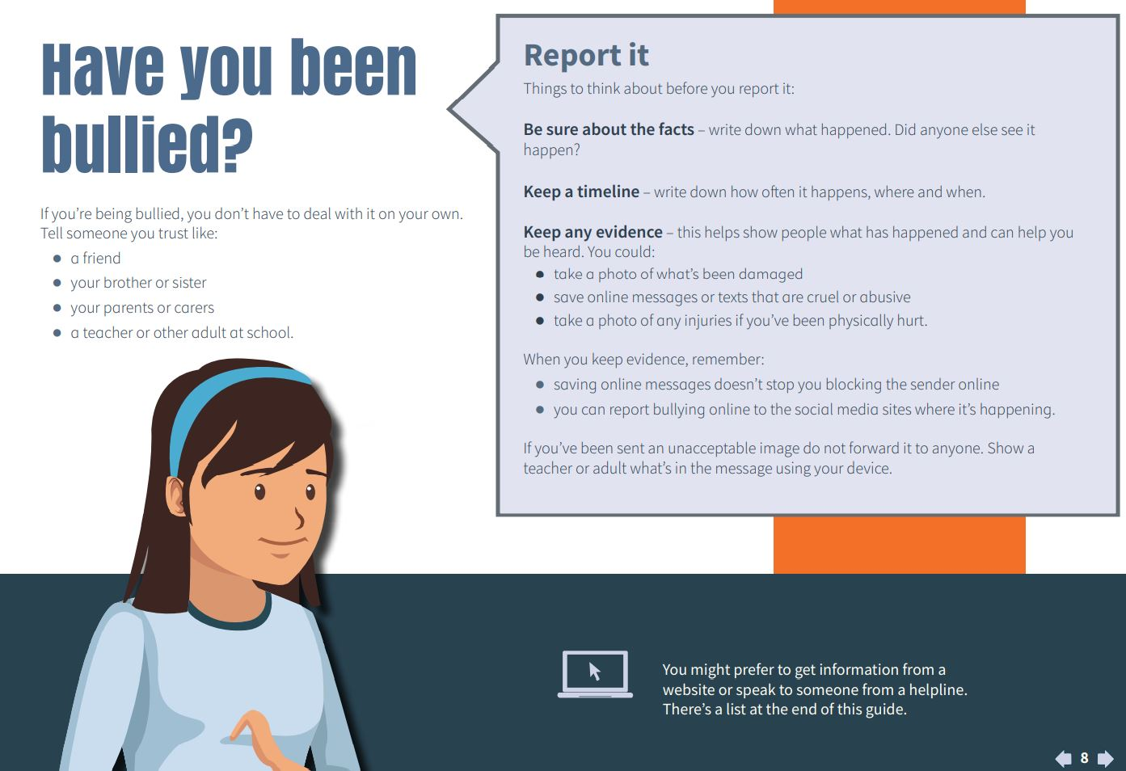
What can I do if I am being bullied?

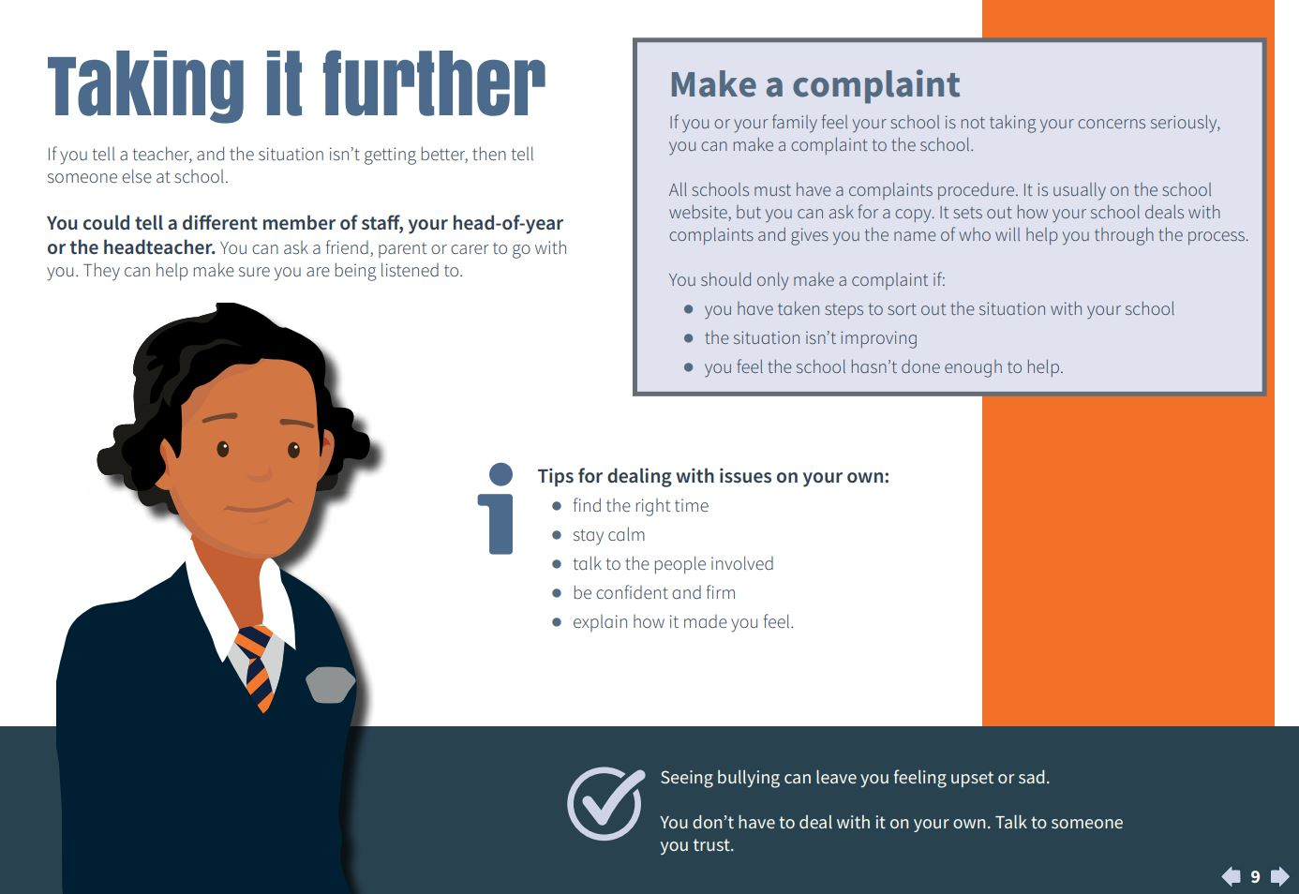
- Schools must have a Challenging Bullying policy and must deal with incidents of bullying, so tell a teacher. The school will want to know if you being targeted by bullying behaviours and will want to help you.
- Tell your parents and your friends. Ask your friends to look out for you
- Help yourself by trying to ignore the bully
- Act as though you don’t care what they say or do
- Use eye contact and firmly tell them to go away
- Walk away
- Try not to cry or look upset as bullies want to get a reaction
- Stay calm and try not to get angry
- Don’t fight back as this could make the situation worse
- Keep a record of all the events – time and place and what happens. Save any nasty texts or emails
- Think about when and where it happens, and try to avoid these places
- If possible, stay away from the bullies, or stay with a group when you don’t feel safe
- Practise “walking tall”. Try to look positive and confident even if you are not
- Never respond to nasty texts, emails or comments on social networking sites that you have received and always save them for evidence.
- Remember - it is not your fault – no-one deserves to be bullied
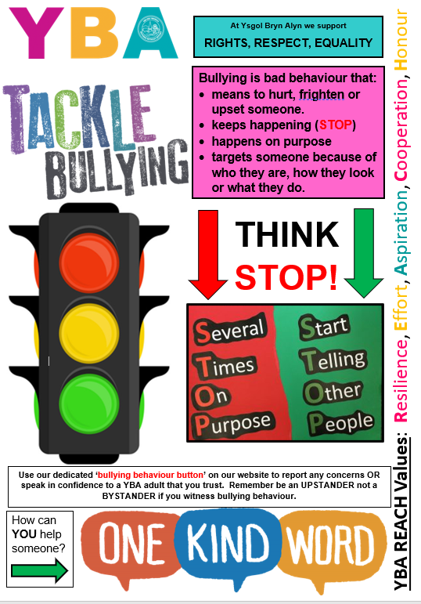

Appendix 3b)
Bullying Advice for Parents and Carers

What is bullying?

There are many definitions of bullying; most contain reference to the following characteristics:

- it tends to be prolonged and repeated;
- it involves an imbalance of power between victim and perpetrator;
- it may be physical, verbal or psychological.

Bullying behaviour is a complex issue that may be defined as the intentional abuse of power by an individual or group with the intent of causing concern or distress to another individual or group. It may occur on a regular or irregular basis; every reported incident should be treated seriously and be thoroughly investigated.

Bullying behaviour is experienced by significant numbers of children and young people; adults should be vigilant in looking for possible incidents. Bullying behaviour and harassment can seriously blight lives and cause acute unhappiness and anxiety. This can lead to changes to the target’s behaviour causing hindrance to academic progress, truancy and self-harming.

Those pupils who display bullying behaviours are not all the same. They can be:

- aggressive and physically intimidating and act in gangs to harass their targets
- anxious pupils who join bullying groups to avoid adverse attention themselves;
- pupils who have been targets of bullying behaviours who turn to displaying this behaviour towards weaker youngsters after having suffered bullying behaviours themselves;
- perpetrators who taunt and disparage their target effectively attacking the target’s self-esteem;
- perpetrators who spread harmful stories or hint at possible negative outcomes to their targets.

Targeted pupils also differ in nature. Some examples can be:

- looked after children;
- children with special education needs;
- children who have a different mode of speech or appearance from others. This would include those from different ethnic backgrounds to the majority;
- anxious or nervous children with low self-esteem;
- children with under-developed social skills;
- attention seeking individuals who provoke others or seek the role of the target.
- newcomers to school, class, social group or neighbourhood

Sexual or racial harassment are forms of bullying. The former is most often perpetrated by boys
against girls and is more often than not an abuse of physical power. The Commission for Racial Abuse defines abuse of a racist nature as “violence, which may be verbal or physical, including attack on property as well as the person. This may be suffered by individuals or groups because of their colour, race, nationality or ethnic origins, when the victim believes the perpetrator was acting on racial ground”.

Not all aggressive behaviour is bullying behaviour. Some behaviour, particularly with very young children, might be aggressive but have no knowing intent to cause distress or injury. Pupils who report that they feel targets of bullying behaviours when they may not have been, may ned support. Adults in these types of instances need to carefully explain the differences between bullying behaviours and being isolated, though regrettable, acts of aggression that might be a one-off incident.

Bullying behaviours are an intentional abuse of relational power.

There are other types of negative behaviour, which are sometimes mistaken for bullying.
Squabbles, quarrels, pushing and shoving should not automatically be seen as bullying. Children and adults quarrel from time to time and it is not bullying if there is no imbalance of power.
It is important that schools recognise the difference between conflict and bullying behaviours, which is typically surrounded by a complex web of deceit and power misuse.

What are the signs of bullying?
Indicators that a child is being bullied could include:

- Reluctance to go to school
- Appearing frightened of / during the journey to and from school
- Changing their usual route
- Being anxious, moody, withdrawn, quiet
- Complaining of illnesses such as stomach aches and headaches
- Bed-wetting in a previously dry child or young person
- Having nightmares or sleeping difficulties
- Coming home regularly with missing or damaged possessions
- Arriving home hungry
- Asking for extra money or stealing money
- Truanting
- Deterioration in their work / handwriting
- Not eating
- Unexplained cuts and bruises
- Being aggressive and bullying others
- Giving improbable excuses for any of the above

How can parents/carers help?

- Give reassurance to your child that it is not their fault
- Talk calmly about what is happening even though you may feel upset yourself
- Listen to your child and take what they say seriously
- Encourage your child to report incidents to a member of staff
- Make notes of what has happened (who, what, when, where)
- Talk to the school or organisation
- Do not confront the bully or parents yourself-work with the school or other organisation

Talking to the school

Schools must have a challenging bullying policy. It should make clear the strategies it will use in response to bullying incidents. Schools have a duty to promote positive behaviour and have strategies to prevent bullying incidents occurring.

- Tell the school about the incident
- Try and stay calm the school may have had no idea that your child is being bullied or may have heard conflicting accounts of the incident
- Give as much detail of the incident as you can - time, location, what happened, names of those involved including witnesses
- Arrange a meeting with school staff
- The school should investigate the incident before the meeting
- Take written details of the incident to the meeting
- Ask for notes to be taken so that there is a record of what is discussed and agreed
- Ask for a named contact at the school for both you and your child
- Stay in touch with the school and let them know if things improve as well as if problems continue
- Agree a plan of action and a time for a follow up meeting

After the meeting

- Write to the school outlining what you think was agreed at the meeting.
- Give the school time to deal with the incident but agree a deadline with the school
- Talk to your child about what is happening

Appendix 4

https://www.estyn.gov.wales/blog/why-we-need-keep-talking-about-bullying

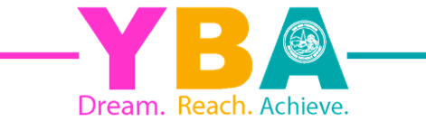
Appendix 5

Ysgol Bryn Alyn Challenging Bullying Policy

1) Objectives of this Policy

Ysgol Bryn Alyn Challenging Bullying Policy outlines what Ysgol Bryn Alyn will do to tackle bullying behaviours. The policy has been drawn up with the involvement of the whole school community.

2) Our school community:

- Discusses, monitors and reviews our Rights, Respect, Equality - Challenging Bullying Policy annually.
- Supports staff to promote positive relationships, to identify and tackle bullying behaviours appropriately.
- Ensures that pupils are aware that all bullying concerns will be dealt with sensitively and effectively; that pupils feel safe to learn; and that pupils abide by the challenging bullying policy.
- Reports back to parents/carers regarding their concerns about bullying behaviours and deals promptly with complaints. Parents/ carers in turn, work with the school to uphold the Rights, Respect, Equality – Challenging Bullying policy.
- Seeks to learn from good challenging bullying practice elsewhere and utilises support from the Local Authority and other relevant organisations when appropriate.

3) Definition of bullying

Behaviour by an individual or group, usually repeated over time, that intentionally hurts others either physically or emotionally.

This definition has been agreed by the YBA School Council and has been shared with pupils and staff across the school.

4) Forms of bullying covered by this Policy

Type | Example
Physical Bullying | - Kicking or hitting  - Prodding, pushing or spitting  - Other physical assault  - Intimidating behaviour  - Interference with physical property
Verbal/Psychological | - Threats or taunts  - Shunning/ostracism  - Name calling/verbal abuse  - humiliation  - Spreading rumours  - Making inappropriate comments in relation to appearance  - Extortion / intimidation
Emotional | - Behaviour intended to isolate, hurt or humiliate someone
Indirect | - Sly or underhand actions carried out behind the target’s back or rumour-spreading
Online | - using any form of technological means, mobile phones, social networks,  - gaming, chat rooms, forums or apps to bully via text, messaging, images or video
Socio-economic Status | - Negative stereotyping, name calling or ridiculing based on financial circumstances
Relational aggression | - bullying that tries to harm the target’s relationships or  social status:  - drawing their friends away,  - exploiting a person’s special educational needs (SEN) or long-term illness,  - targeting their family’s social status,  - isolating or humiliating someone or deliberately getting someone into trouble
Sexist | - Use of sexist language  - Negative stereotyping based on gender
Sexual | - Unwanted/inappropriate physical contact  - Sexual innuendo  - Suggestive propositioning  - Distribution/display of pornographic material aimed at an individual  - Graffiti with a sexual content aimed at an individual  - sextortion, so called ‘revenge porn’ and any  misuse of intimate, explicit images of the learner targeted
Prejudice-related | - bullying of a learner or a group of learners because of  prejudice. This could be linked to stereotypes or presumptions about identity. Prejudice-related bullying includes the protected characteristics (age, disability, gender reassignment, pregnancy, race, religion or belief, sex and sexual orientation).  - Prejudice can and does also extend beyond the protected characteristics and can lead to bullying for a variety of other reasons such as social status and background.

5) Preventing, identifying and responding to bullying behaviours

We will:
- Work with staff and outside agencies to identify all forms of prejudice-driven bullying behaviours based on protected characteristics.
- Actively provide systematic opportunities to develop pupils’ social and emotional skills, including their resilience.
- Consider all opportunities for addressing bullying behaviours through the curriculum, displays, peer support and the School Council.
- Train all staff including lunchtime staff and learning mentors to identify bullying behaviours and follow school policy and procedures on incidences of this nature.
- Actively create “safe spaces” for vulnerable children and young people
- Ensure any report made via our ‘Bully Button’ on the YBA website is acted upon where pupils, parents and members of the community can report incidences of bullying behaviours as a target and a bystander.
- Act on any incidences of bullying behaviours in conjunction with the YBA Behaviour Policy if sanctions are required.

6) Involvement of pupils / students

We will:
- Regularly canvas children and young people’s views on the extent and nature of bullying behaviours.
- Ensure students know how to express worries and anxieties about incidences of bullying behaviours.
- Ensure all students are aware of the range of sanctions that may be applied against those engaging in bullying.
- Involve students in our Rights, Respect, Equality – Challenging Bullying campaign at YBA.
- Publicise the details of helplines and websites.
- Offer support to students who have been targets of bullying behaviours.
- Work with students who have been perpetrators of bullying behaviours in order to address the problems they have.

7) Liaison with parents and carers

We will:
- Ensure that parents / carers know whom to contact if they are worried about bullying behaviours.
- Ensure parents know about our complaints procedure and how to use it effectively.
- Ensure parents / carers know where to access independent advice about bullying behaviours.
- Work with parents and the local community to address issues beyond the school gates that give rise to bullying behaviours.

8) Monitoring & review, policy into practice

We will review this Policy annually as well as when incidents occur that suggest the need for review. The school uses the guidance by the Welsh Government regarding Rights, Respect & Equality to inform its action planning to challenge bullying behaviours.

9) Responsibilities

This Policy only works if it ensures that the whole school community understands that bullying is not tolerated and understands the steps that will be taken to both prevent and respond to bullying.

It is the responsibility of:

- Student & Staff Wellbeing Governors Committee to take a lead role in monitoring and reviewing this policy.
- Governors, the Headteacher, Senior Leaders Teaching and Non-Teaching staff to read this policy and implement it accordingly.
- The Headteacher to communicate the policy to the school community.
- Pupils to abide by the policy.

Please use this policy alongside the following additional YBA policies;
YBA Behaviour Policy
YBA Child Protection Policy
YBA Relationships 7 Sexuality Education Policy

The named contact for this policy is the Deputy Headteacher (Pastoral)

Appendix 5 b)

CHECKLIST FOR CHALLENGING BULLYING POLICY

Has the organisation consulted widely in developing its policy? E.g. Pupils, staff, governors and parents/carers?

Does the policy acknowledge that the organisation considers bullying behaviours to be unacceptable and is committed to dealing with it?

Are staff/pupils’ views on bullying sought regularly and is it clear how they can contribute ideas about how to tackle bullying?

Does the policy define what the organisation considers bullying to be?

Is it clear and age-appropriate?

Does the policy identify types of bullying behaviour?

Do we keep a record of bullying incidents and analyse it for patterns-people, places and groups?
Does the policy ensure that pupils/staff are aware that all bullying concerns will be dealt with sensitively and effectively and support offered to those who have been bullied?
Does the policy ensure that all pupils/staff are aware of the disciplinary processes for those involved in bullying incidents
Do the aims and objectives include supporting pupils who have been perpetrators in order to address the problems they have?
Are there clear procedures for reporting incidents of bullying behaviours for pupils/staff?

Do parents/carers know who to contact if they are worried about bullying behaviours?

Do parents/carers know about the complaints procedure and how to use it?

Are teaching and non-teaching staff clear about their responsibilities?

Does the policy identify a range of strategies that can be used by parents/carers, pupils and the organisation as a whole to reduce bullying behaviours?
Are there clear processes for the policy to be monitored and its aims restated to the whole organisation?

Appendix 6
Schools Travel Code
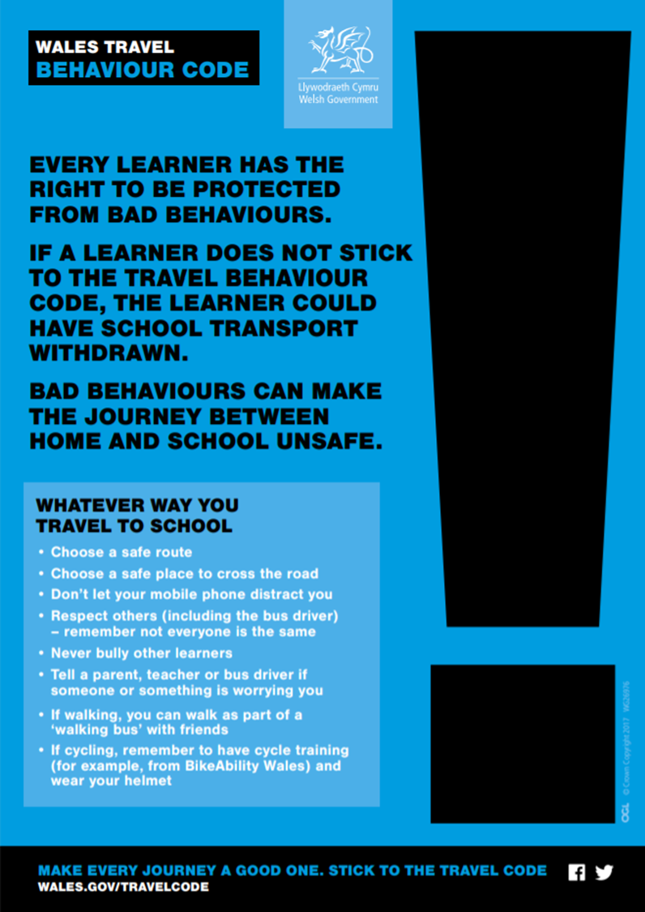
Appendix 7
ADVICE, COUNSELLING AND SUPPORT ORGANISATIONS

It should be noted that Wrexham Council is not responsible for the content or reliability of the linked websites. Listing should not be taken as endorsement of any kind. We cannot guarantee that these links will work all the time and we have no control over the availability of linked pages.

Useful Websites and telephone numbers (taken from Rights, Respect, Equality (2019) Statutory Guidance for Governing Bodies of Maintained Schools):

Where to find further help and advice

Bullying

Bullies Out – Anti-bullying charity based in Wales that works with individuals, schools,
colleges, youth and community settings. E-mentors offer online support
(e-mail mentorsonline@bulliesout.com).
www.bulliesout.com
e-mail: mail@bulliesout.com

Anti-Bullying Alliance – Information for schools, parents/carers and children and
young people on all aspects of bullying.
www.anti-bullyingalliance.org.uk

Kidscape – Anti-bullying charity that runs workshops for children and young people who have been bullied.
www.kidscape.org.uk

The Diana Award – Trains young anti-bullying ambassadors to help others.
www.antibullyingpro.com
Helplines and support services

General

Samaritans – Charity dedicated to reducing feelings of isolation and disconnection that
can lead to suicide. E-mail, live chat and other services available.
www.samaritans.org
Tel: 116 123 (English-language line – free to call)
Tel: 0808 164 0123 (Welsh-language line – free to call)

Rethink Mental Illness – Advice and information for people with mental health issues.
www.rethink.org
Tel: 0300 500 0927

Mencap Cymru – Advice and information about learning disabilities.
https://wales.mencap.org.uk
Tel: 0808 8000 300

Children and young people

Meic – Information advice and advocacy for young people.
www.meiccymru.org

Childline – Provide counselling for anyone aged under 19 in the UK.
www.childline.org.uk
Tel: 0800 1111

Kooth – Online counselling and emotional well-being platform for children
and young people.
www.kooth.com

CALL (Community Advice and Listening Line) – Emotional support and
information/literature on mental health and related matters for the people of Wales.
www.callhelpline.org.uk

Parents/carers

Family Lives – Support and advice for parents/carers.
Tel: 0808 800 2222

ParentZone – Support and advice for parents/carers.
www.parentzone.org.uk

YoungMinds – Support to help improve the mental health of children and young people.
www.youngminds.org.uk
Tel: 0808 802 5544 (parents’/carers’ helpline)

Schools/professionals

Professionals Online Safety Helpline – For those working with children and
young people who require help for an online issue.
Tel: 0344 381 4772
e-mail: helpline@saferinternet.org.uk

Advice and support networks
General

Internet Watch Foundation – For reporting online images of child sexual abuse.
www.iwf.org.uk

Victim Support – Report hate crime in Wales.
www.reporthate.victimsupport.org.uk

CEOP (Child Exploitation and Online Protection) – If child sexual abuse or exploitation
is suspected.
www.ceop.police.uk

NSPCC – National Society for the Prevention of Cruelty to Children.
www.nspcc.org.uk
Tel: 0808 800 5000

Mental Health Matters Wales – Works with people who have a mental
health-related issue.
www.mhmbcb.com/index.htm74

Children and young people

Heads Above The Waves – Support for children and young people suffering depression or self-harming.
http://hatw.co.uk/straight-up-advice

Parents/carers

Internet Matters – Advice on online issues for parents/carers and children and
young people.
www.internetmatters.org.uk

Resources for schools

EACH (Educational Action Challenging Homophobia) – Provide services to inspire
lesbian, gay, bisexual and trans equality.
https://each.education

Show Racism The Red Card – Training and resources to tackle racism in society.
www.theredcard.org

The ACE Support Hub Wales – Toolkit for school staff on ACEs.
www.wales.nhs.uk/sitesplus/888/page/88504

South West Grid for Learning (SWGfL) – Self-evaluation tool for schools and guidance.
www.swgfl.org.uk

Other

School Beat – All Wales School Liaison Core Programme.
www.schoolbeat.org/en/parents/know-the-programme/national-events/what-isthe-all-wales-school-liaison-core-programme

Children in Wales – www.childreninwales.org.uk/our-work/bullying

Children’s Commissioner for Wales – www.childcomwales.org.uk

Time to Change Wales – Campaign for young people, which aims to change attitudes
towards mental health, ending stigma and discrimination.
www.timetochangewales.org.uk/en/mental-health-stigma/young-people/wecanwewill

Online issues

Childnet International – Support on all aspects of online safety.
www.childnet.co

